RAG Chatbot AI Governance Evaluation
Backend Flow - Standard-Driven Evaluation Architecture
July 2026

1. Architecture Overview

Core Principle: Evaluation Follows Selection
The system does not run a fixed checklist against every client. Instead, the user tells the system which industry they operate in and which compliance standards matter to them, and the backend evaluates the chatbot only against those standards - nothing more, nothing less.
This is the defining characteristic of the platform: dynamic, standard-driven evaluation.
INDUSTRY SELECTED -> STANDARDS RECOMMENDED -> USER PICKS 1-3 -> EVALUATE ONLY THOSE -> ONE REPORT PER STANDARD

Why This Works
Each compliance standard already contains its own governance, security, and risk requirements internally - there is no need to run separate, generic engines for those concepts. The evaluation engine simply loads the control pack for whichever standard was selected and tests every control inside it:
- ISO 42001 covers AI policy, data security, and bias testing within its 38 Annex A controls
- HIPAA covers admin safeguards, technical safeguards, and physical safeguards within its own structure
- NYC LL144 covers auditor requirements, bias testing, and transparency disclosures
Underneath these standard-specific structures, every individual control is also tagged to one of 5 common governance pillars (Trust, Security, Governance, Compliance, Data Protection) so that results stay comparable across industries and standards, and so the system can automatically detect when fixing one gap satisfies requirements in multiple standards at once. See Section 6.

2. Complete Pipeline Flow
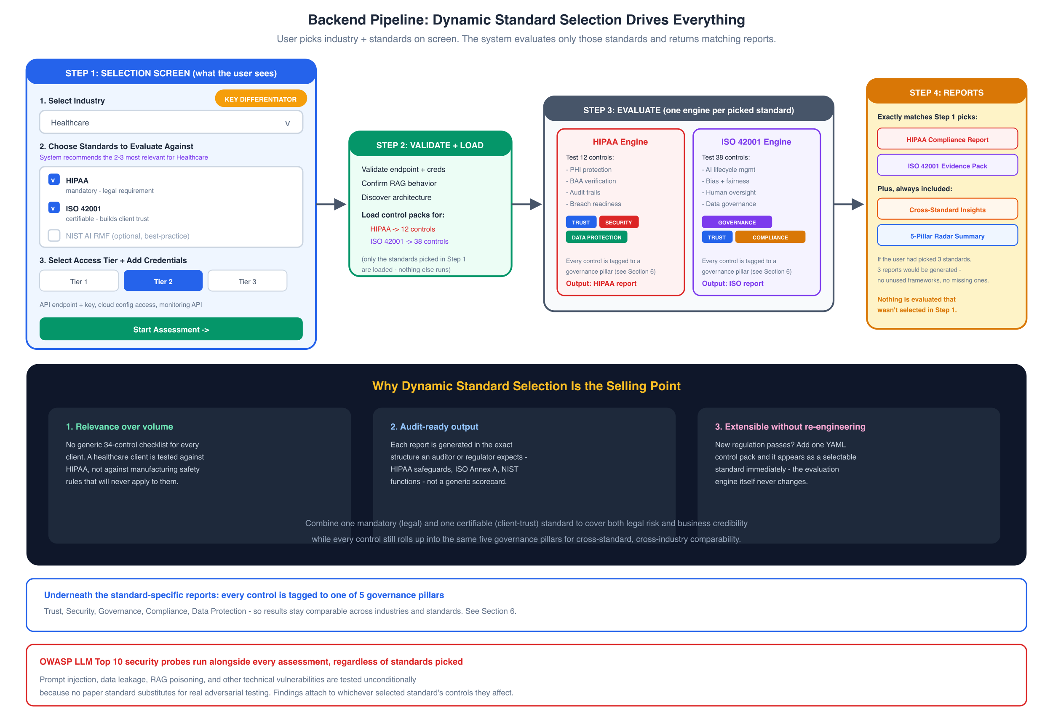

Pipeline Steps
Step 1: Selection Screen: Select industry, get recommended standards pre-checked, adjust as needed, select tier, provide credentials.
Step 2: Validate + Load: Validate endpoint, confirm RAG behavior, discover architecture, load control packs only for selected standards.
Step 3: Evaluate: Each standard gets its own parallel engine. Controls filtered by tier. Every control pillar-tagged. OWASP runs alongside.
Step 4: Reports: One report per selected standard in native format, plus cross-standard insights and a 5-pillar radar summary.

3. Dynamic Standard Selection - The Core Differentiator
Selecting the right standards is the single most important decision a user makes, and the platform is built around making that decision easy and defensible.

How It Works
- User selects industry (e.g. Healthcare, Finance, HR/Recruitment, Education, Autonomous Vehicles, etc.)
- System looks up the industry-to-standard mapping and pre-selects the 2-3 most popular, most relevant standards
- Each recommended standard shows why it's recommended - mandatory/legal, certifiable/business-trust, or methodological/best-practice
- User can add or remove standards from the list, or search for additional ones
- The evaluation engine loads exactly those control packs - no more, no less
- Reports come back in the native format of each selected standard, plus a cross-standard insights view

Why This Is the Selling Point
Benefit | What It Means in Practice
Relevance over volume | No generic 34-control checklist for every client. A healthcare client is tested against HIPAA, not manufacturing rules
Audit-ready output | Each report matches the exact structure an auditor or regulator expects - not a generic scorecard
Extensible without re-engineering | A new regulation passes? Add one YAML control pack - it appears as a selectable standard immediately
Combines legal + business needs | Users are guided to pick one mandatory + one certifiable standard, covering legal risk and business credibility
Cross-standard efficiency | Pillar-tagging automatically finds gaps affecting multiple standards, avoiding duplicated remediation effort

4. Industry-Based Standard Recommendations
Industry | Standard 1 | Standard 2 | Standard 3
Healthcare | HIPAA (mandatory) | ISO 42001 | NIST AI RMF
Finance/Banking | MAS AI / SR 11-7 | SOC 2 Type II | ISO 42001
Insurance | NAIC Model Bulletin | ISO 42001 | EU AI Act
HR/Recruitment | NYC LL144 (mandatory) | Colorado AI Act | EU AI Act
Education | FERPA | NIST AI RMF | ISO 42001
Autonomous Vehicles | UNECE ADS Reg | ISO 21448 (SOTIF) | UK AV Act 2024
Legal/Judiciary | CEPEJ Charter | EU AI Act | Canada AIA
Manufacturing | EU Machinery Reg | IEC 62443 | ISO 13849
Media/Content | China Deep Synthesis | C2PA Standard | EU AI Act
Government | US OMB M-24-10 | Canada AIA | Netherlands IAMA

Why Multiple Standards?
Type | What It Does | Example
Mandatory/Regulatory | Legal requirement | HIPAA, NYC LL144, EU AI Act
Certifiable | Get a certificate for clients | ISO 42001, SOC 2
Methodological | Best-practice guidance | NIST AI RMF, CEPEJ Charter
Most organizations need two: one mandatory (legal) and one certifiable (business trust). The third standard is optional for comprehensive coverage.

5. Three-Tier Access Model
The tier determines how many controls within each standard can actually be tested.
Tier | Access Level | What You Provide | Coverage
Tier 1 | API Only | Chatbot endpoint + API key | ~55-60%
Tier 2 | API + Infrastructure | + Cloud API keys, monitoring, CI/CD | ~80-85%
Tier 3 | Full Source + Staging | + Source repo, staging env, model registry | 100%

What Each Tier Unlocks

Tier 1 (Black-Box):
- Prompt injection testing
- Data leakage probes
- Output filtering checks
- Response consistency analysis
- Hallucination detection
- Self-reported compliance questionnaire probes

Tier 2 (adds Gray-Box):
- Cloud configuration audit (AWS/GCP/Azure APIs)
- Monitoring and logging verification
- CI/CD pipeline security checks
- Access control configuration review
- Encryption verification
- Network isolation checks

Tier 3 (adds White-Box):
- Source code review
- Model card verification
- Training data audit
- Vector DB content scanning
- Staging environment penetration testing
- Full dependency vulnerability scan

Tier Coverage by Standard
Standard | Tier 1 | Tier 2 | Tier 3
HIPAA | 7/12 controls | 10/12 | 12/12
ISO 42001 | 22/38 controls | 32/38 | 38/38
NIST AI RMF | 15/27 controls | 23/27 | 27/27
EU AI Act | 12/22 controls | 18/22 | 22/22
SOC 2 Type II | 8/17 controls | 15/17 | 17/17
NYC LL144 | 6/8 controls | 7/8 | 8/8
Controls that cannot be tested at the current tier are marked "Not Assessed - requires Tier X" with confidence scored at 0.

6. Governance Pillars and Trustworthy-AI Characteristics
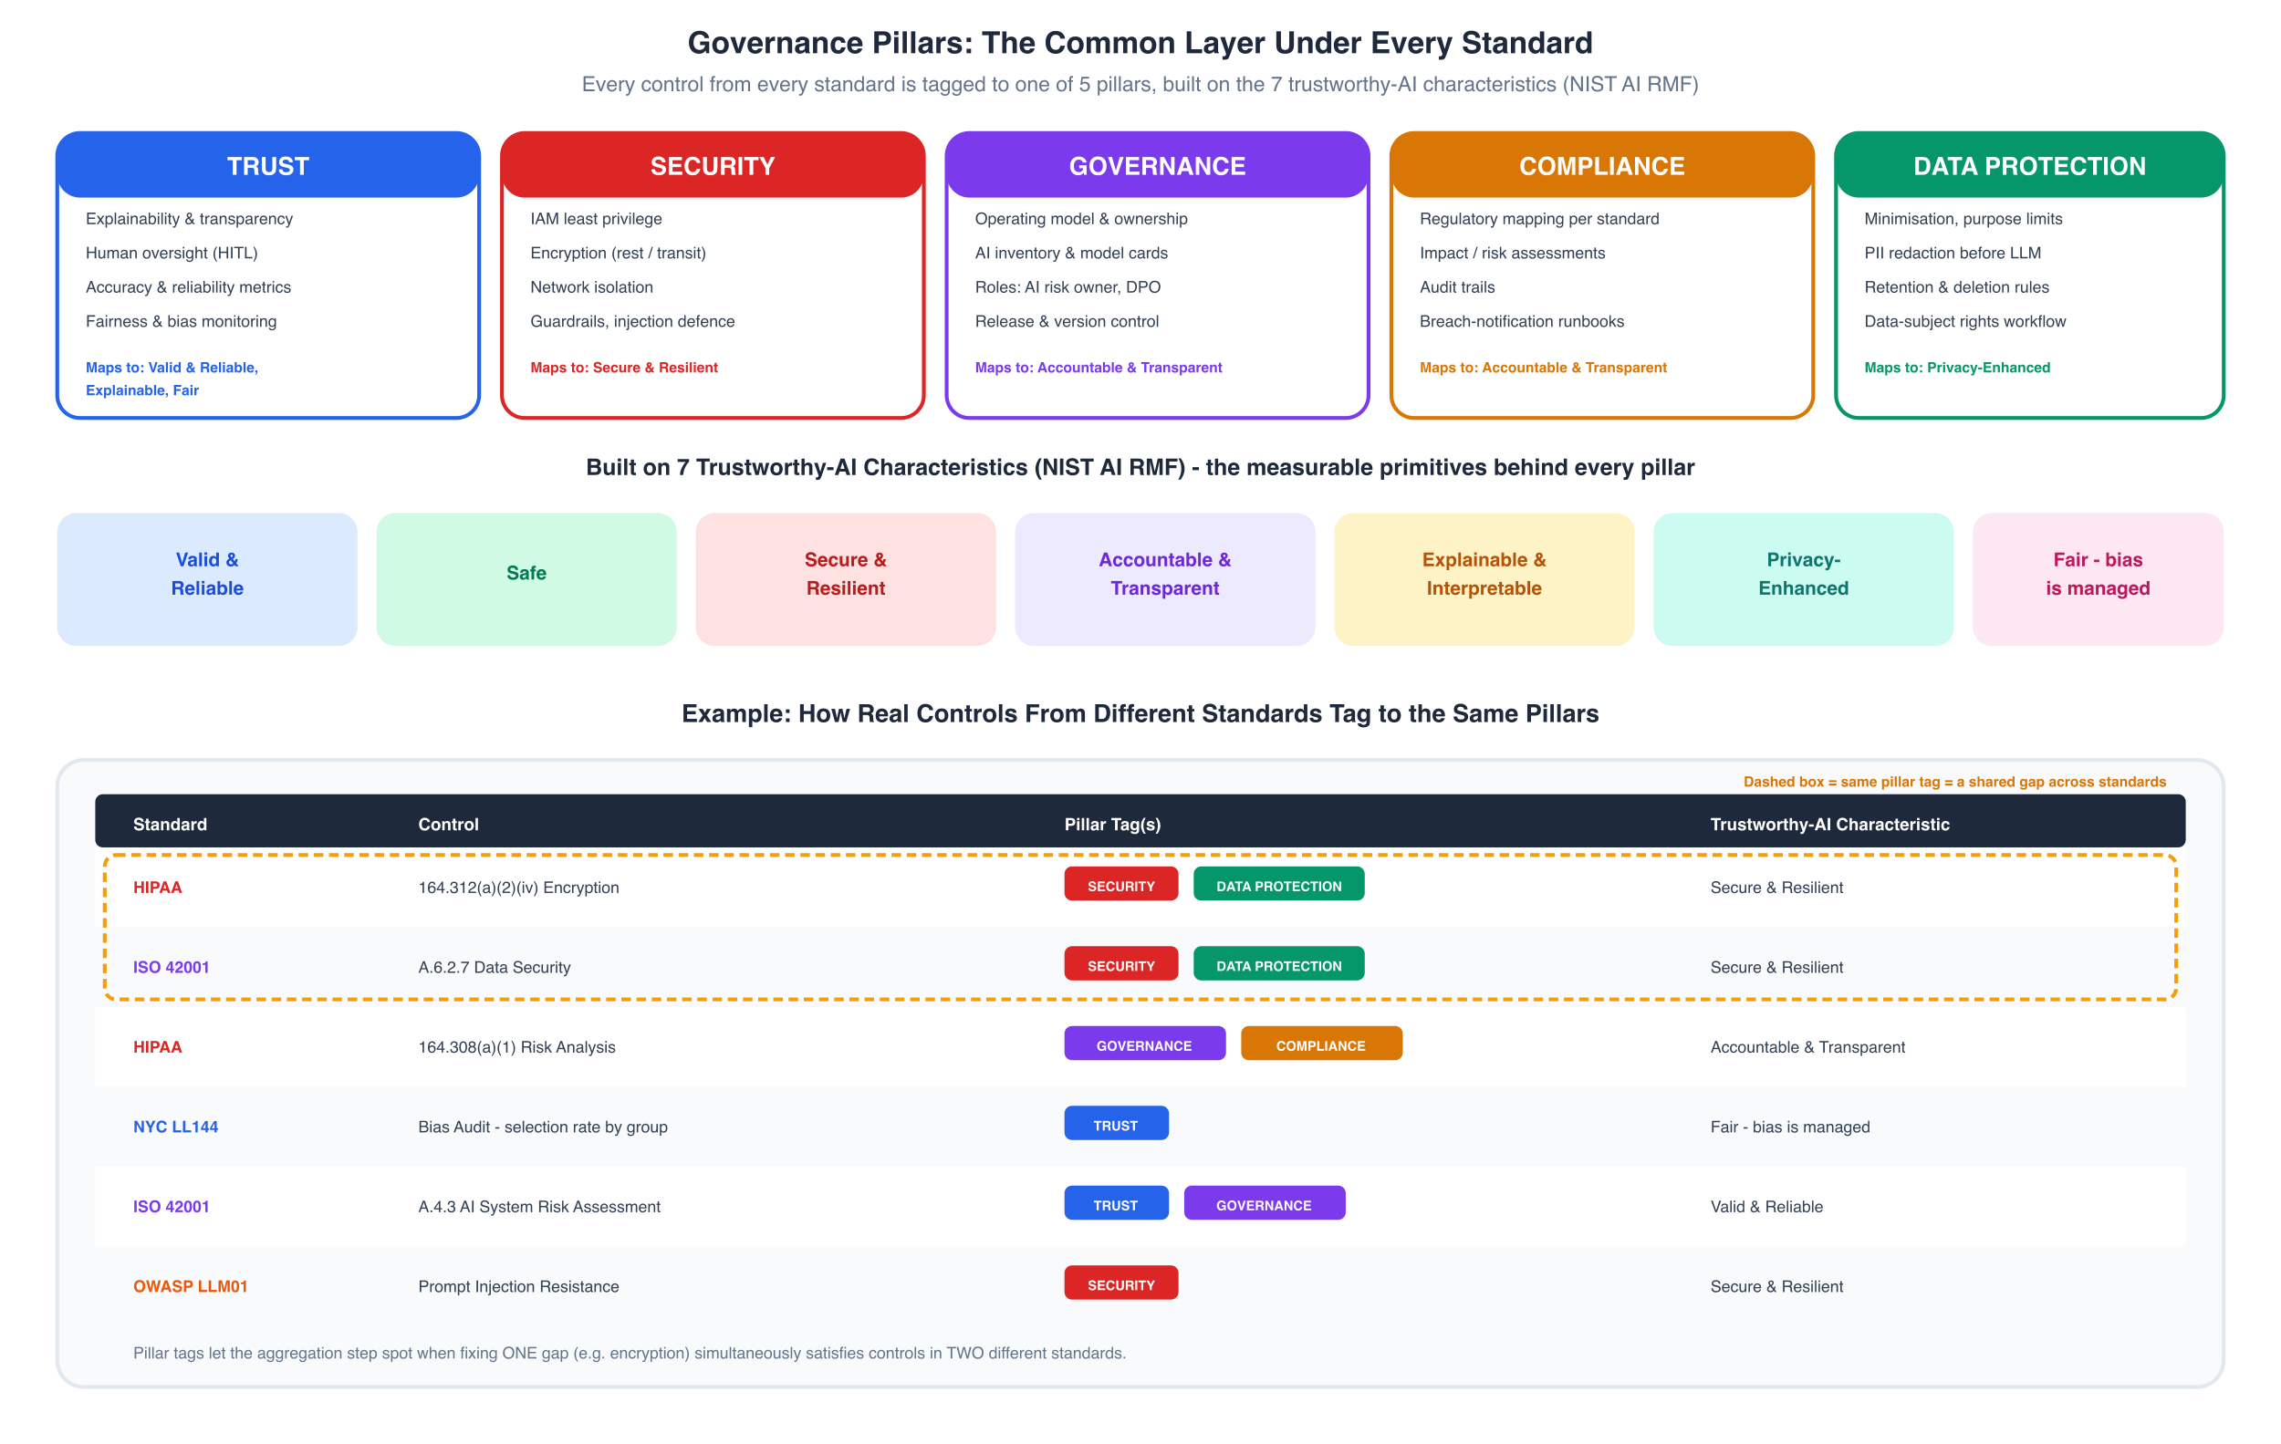

The Common Layer Under Every Standard
Even though evaluation is organized by standard, every single control - regardless of which standard it comes from - is tagged to one of 5 governance pillars:
Pillar | Covers | Built on (NIST Characteristics)
Trust | Explainability, human oversight, accuracy, fairness/bias monitoring | Valid & Reliable, Explainable, Fair
Security | IAM, encryption, network isolation, guardrails, injection defence | Secure & Resilient
Governance | Operating model, AI inventory, model cards, roles, release control | Accountable & Transparent
Compliance | Regulatory mapping, impact assessments, audit trails, breach runbooks | Accountable & Transparent
Data Protection | Minimisation, PII redaction, retention rules, data-subject rights | Privacy-Enhanced

These 5 pillars are themselves built on the 7 trustworthy-AI characteristics defined by the NIST AI Risk Management Framework: Valid & Reliable, Safe, Secure & Resilient, Accountable & Transparent, Explainable & Interpretable, Privacy-Enhanced, and Fair (bias managed).

Why Pillar Tagging Matters
- Cross-standard comparability - a client running HIPAA + ISO 42001 can see how they are doing on "Security" overall, not just per standard
- Shared-gap detection - if controls from two standards both tag to "Security" and both fail for the same underlying reason, the system flags one fix that resolves two findings
- Consistent executive reporting - leadership gets a simple 5-pillar radar chart regardless of which specific standards were evaluated
- Future-proofing - new standards plug directly into existing dashboards and cross-standard insight logic with no extra engineering

Example: Same Pillar, Different Standards
Standard | Control | Pillar Tag(s) | Characteristic
HIPAA | 164.312(a)(2)(iv) Encryption | Security, Data Protection | Secure & Resilient
ISO 42001 | A.6.2.7 Data Security | Security, Data Protection | Secure & Resilient
HIPAA | 164.308(a)(1) Risk Analysis | Governance, Compliance | Accountable & Transparent
NYC LL144 | Bias Audit - selection rate | Trust | Fair (bias managed)
ISO 42001 | A.4.3 AI System Risk Assessment | Trust, Governance | Valid & Reliable
OWASP LLM01 | Prompt Injection Resistance | Security | Secure & Resilient
Because the HIPAA encryption control and the ISO 42001 data security control share the same pillar tags, fixing the underlying encryption gap resolves both findings at once - this is exactly what the Cross-Standard Insights report surfaces.

7. Per-Standard Evaluation Engine
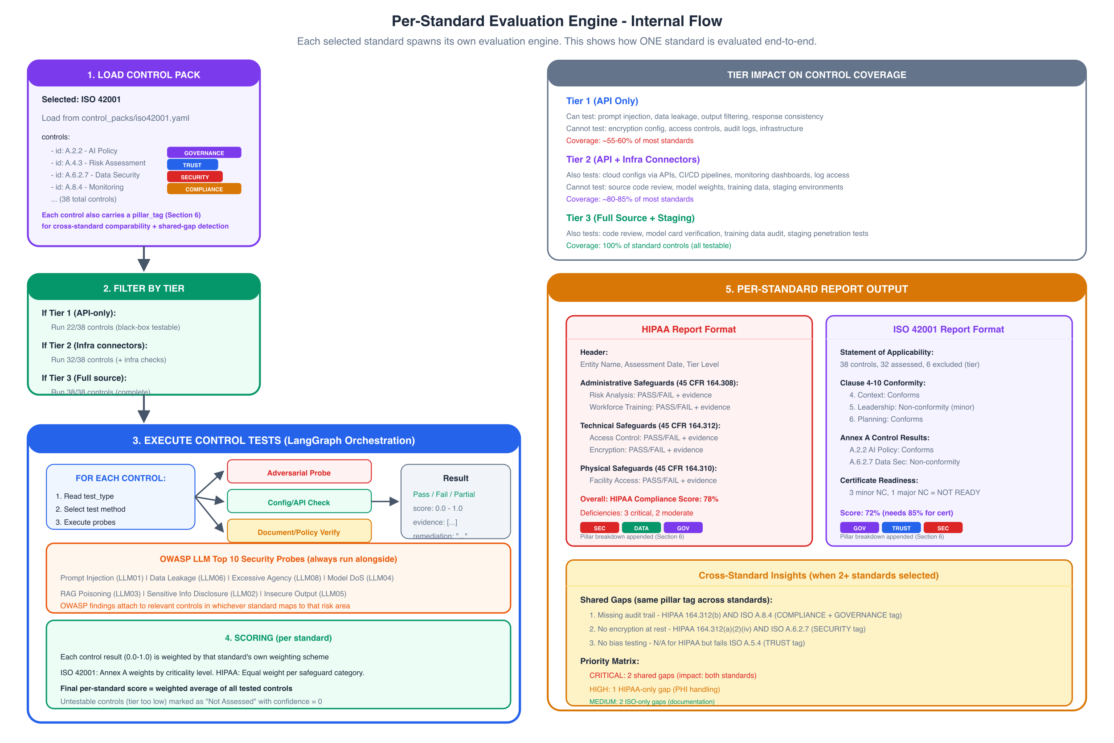

Each selected standard follows: LOAD CONTROL PACK -> FILTER BY TIER -> EXECUTE TESTS -> SCORE -> FORMAT REPORT

Test Types
Test Type | How It Works | Tier Required | Example
Adversarial Probe | Crafted inputs to chatbot API | Tier 1+ | Prompt injection, data extraction
Config Check | Query infrastructure APIs | Tier 2+ | Encryption enabled, logs configured
Document Verify | Check policy existence/content | Tier 3 | Model card, bias testing report

OWASP LLM Top 10 (Always Included)
Regardless of selected standards, OWASP security probes always run. Findings map to relevant controls in selected standards via shared pillar tags.
OWASP ID | Vulnerability | Test Method | Pillar Tag
LLM01 | Prompt Injection | Direct + indirect injection attempts | Security
LLM02 | Sensitive Info Disclosure | PII extraction probes | Security, Data Protection
LLM03 | Training Data Poisoning | RAG retrieval manipulation | Security, Trust
LLM04 | Model Denial of Service | Resource exhaustion probes | Security
LLM05 | Insecure Output Handling | XSS/injection in responses | Security
LLM06 | Excessive Agency | Tool-use boundary tests | Security, Governance
LLM07 | System Prompt Leakage | Extraction techniques | Security
LLM08 | Vector DB Poisoning | Retrieval integrity checks | Security, Trust

8. Scoring Model
Each standard uses its own native scoring scheme:
Standard | Scoring Method | Pass Threshold
HIPAA | Equal weight per safeguard category | 100% required (regulatory)
ISO 42001 | Conformity: Conforms / Minor NC / Major NC | 0 Major NC for certification
NIST AI RMF | Maturity levels 1-5 per function | Level 3+ recommended
EU AI Act | Mandatory checklist (pass/fail) | 100% for high-risk systems
SOC 2 | Controls effective/not effective | All controls effective
NYC LL144 | 4/5ths rule + disclosure requirements | Statistical threshold

Pillar Rollup Scoring
In addition to the native per-standard score, every assessment also produces a 5-pillar radar score, computed by averaging all tested controls (across all selected standards) that share each pillar tag. This powers the "5-Pillar Radar Summary" shown in every report package, regardless of which specific standards were evaluated.

9. Report Generation

Per-Standard Reports
Each standard generates a report in that standard's native format:

HIPAA Report Structure:
- Entity Information + Assessment Scope
- Administrative Safeguards (45 CFR 164.308) - PASS/FAIL + evidence + pillar tag
- Technical Safeguards (45 CFR 164.312) - PASS/FAIL + evidence + pillar tag
- Physical Safeguards (45 CFR 164.310) - PASS/FAIL + evidence + pillar tag
- Overall Compliance Status + Pillar Breakdown
- Remediation Priority List

ISO 42001 Report Structure:
- Statement of Applicability
- Clause 4-10 Conformity Assessment
- Annex A Control Results (per control, with pillar tag)
- Non-Conformities (Major/Minor)
- Observations and Opportunities for Improvement
- Certificate Readiness Assessment + Pillar Breakdown

Cross-Standard Insights Report
When 2+ standards are selected, an additional insights report is generated, built directly from shared pillar tags:
- Shared Gaps (same pillar tag across standards) - highest priority, fix once, satisfy multiple standards
- Standard-Specific Gaps - unique to one standard only
- Priority Matrix - CRITICAL (shared) > HIGH > MEDIUM > LOW
- 5-Pillar Radar Summary - Trust, Security, Governance, Compliance, Data Protection scores
- Effort Estimate - remediation timeline and resource needs

10. Technical Stack
Component | Technology | Purpose
Orchestration | LangGraph (Python) | State machine for evaluation flow
API Server | FastAPI | REST endpoints + SSE streaming
Control Packs | YAML files | Standard definitions (version-controlled)
Task Queue | Celery + Redis | Parallel standard evaluation
Database | PostgreSQL (Neon) | Assessment results, history
Cache | Upstash Redis | Rate limiting, session state
LLM | GPT-4o / Claude | Probe generation, result analysis
Frontend | Next.js 14 | Input forms + live dashboard
Streaming | Server-Sent Events | Real-time progress to frontend
Reports | WeasyPrint + Jinja2 | PDF generation per standard

11. Frontend Overview
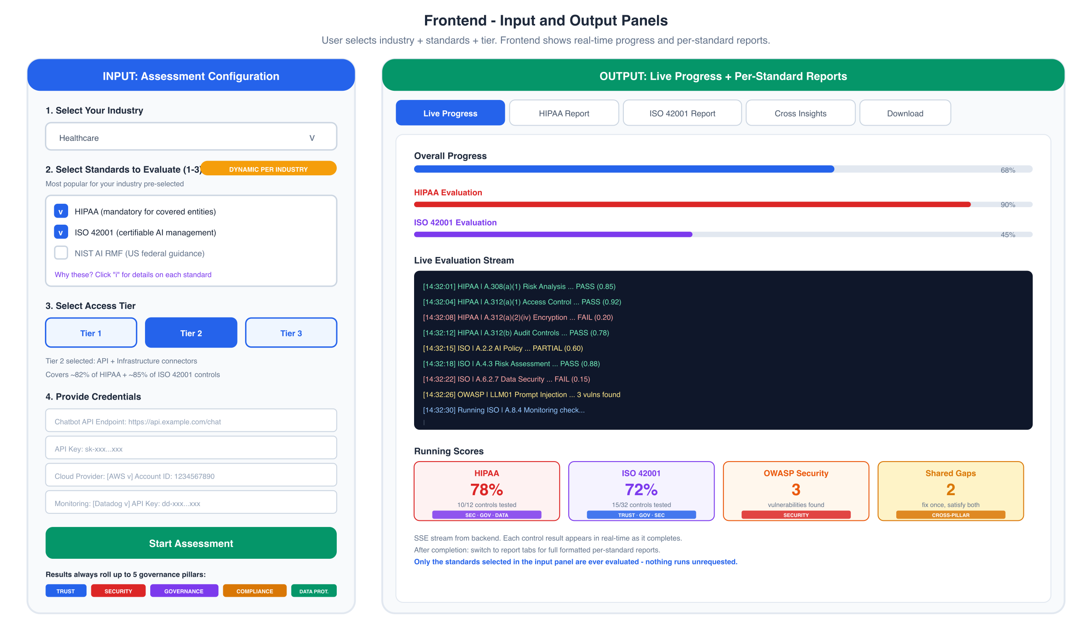

Input Panel
- Industry Selection - dropdown with 10 industries
- Standard Selection - checkboxes (1-3), dynamically pre-populated with the most popular for the selected industry
- Tier Selection - toggle with live coverage % display per selected standard
- Credentials - dynamic form based on selected tier

Output Panel (Tabbed)
Tab | Content
Live Progress | Real-time stream of each control tested, running scores per standard
[Standard 1] Report | Full formatted report in that standard's structure
[Standard 2] Report | Full formatted report in that standard's structure
Cross Insights | Shared gaps, priority matrix, 5-pillar radar summary
Download | PDF per report + combined package
A persistent banner reinforces the core mechanic: "Only the standards selected in the input panel are ever evaluated - nothing runs unrequested."

12. Deployment
Component | Platform | Reason
Frontend | Vercel | Optimized for Next.js
Backend | Railway / Fly.io | Long-running evals (5-15 min)
Database | Neon PostgreSQL | Serverless, auto-scaling
Cache/Queue | Upstash Redis | Serverless Redis
Control Packs | Git repo | Versioned, PR-based updates

13. Adding New Standards
To add a new standard (e.g., a new regulation passes):
- Create control pack: control_packs/new_standard.yaml
- Define controls: id, test_type, tier_minimum, pillar_tags, probes, pass_criteria
- Create report template: reports/templates/new_standard.jinja2
- Add to industry mapping in standards.py
- Test against a sample chatbot, verify pillar tags roll up correctly
No code changes are needed to the evaluation engine itself. The system is entirely data-driven via YAML control packs, and pillar tagging means new standards plug directly into existing cross-standard insight logic and dashboards.

14. Summary
Question | Answer
What drives evaluation? | The industry and standards the user selects on the input screen
How many engines? | One per selected standard (1-3), running in parallel
What about security? | OWASP runs always, maps to standard controls via shared pillar tags
How is output formatted? | Each standard gets its native report format
What if standards overlap? | Cross-insights report shows shared gaps using pillar tags
How do results stay comparable? | Every control rolls up to 5 governance pillars
How to add new standards? | Add a YAML control pack + report template
What determines depth? | Access tier (1/2/3) limits testable controls

